Early Warning Risk & Audit Effectiveness Dashboard Using Power BI
Abstract
In today’s data-driven audit and compliance environment, organizations face increasing exposure to financial risk, fraud, and regulatory violations. Traditional audit approaches are often reactive, identifying risks only after significant damage has occurred. This project presents an Early Warning Risk & Audit Effectiveness Dashboard developed using Power BI, designed to proactively monitor audit quality, financial risk impact, compliance violations, and fraud detection effectiveness.
The dashboard integrates audit, compliance, industry risk, and AI-assisted auditing metrics to provide actionable insights for stakeholders. By leveraging data analytics, KPI tracking, and visual storytelling, the solution enables early identification of high-risk areas, improves audit effectiveness, and supports data-driven decision-making. This project demonstrates the application of business intelligence, risk analytics, and compliance monitoring suitable for real-world enterprise environments.
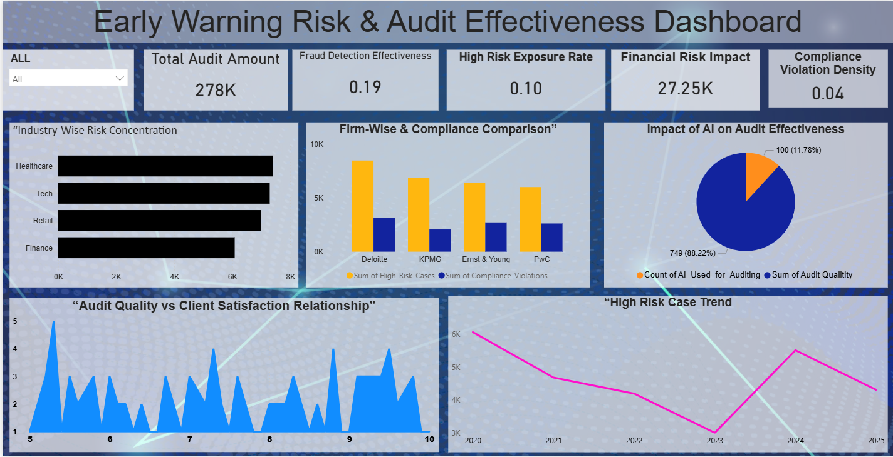

Key Performance Indicators (KPI) Explanation
1. Total Audit Amount
Represents the overall audit exposure handled by firms.
Business Value: Indicates scale and operational responsibility.
2. Fraud Detection Effectiveness
Calculated as:
Fraud Detected / Total Audits
Business Value: Measures the efficiency of audit mechanisms in identifying fraud.
3. High-Risk Exposure Rate
Shows the proportion of audits categorized as high risk.
Business Value: Acts as an early warning indicator.
4. Financial Risk Impact
Total financial loss arising from audit failures or compliance breaches.
Business Value: Directly links audit quality with financial outcomes.
5. Compliance Violation Density
Compliance violations per audit.
Business Value: Evaluates regulatory adherence strength.
Dashboard Visual Analysis
Industry-Wise Risk Concentration
- Identifies industries with the highest audit risk exposure
- Healthcare and Tech show elevated risk levels
- Enables industry-focused risk mitigation strategies
Firm-Wise & Compliance Comparison
- Compares Big4 firms based on:
  - High-risk cases
  - Compliance violations
- Supports benchmarking and competitive audit analysis
Impact of AI on Audit Effectiveness
- Visual comparison between AI usage and audit quality
- Demonstrates that AI-enabled audits improve accuracy and quality
Audit Quality vs Client Satisfaction
- Positive correlation between audit quality and client satisfaction
- Highlights the business value of strong audit governance
High-Risk Case Trend
- Year-wise trend analysis
- Detects risk spikes and improvement periods
- Useful for predictive risk planning
Tools & Technologies Used
- Power BI – Dashboard development & visualization
- DAX (Data Analysis Expressions) – KPI calculations
- Microsoft Excel / CSV – Data storage
- Data Modeling & ETL Concepts
Business Impact & Use Cases
- Enterprise Risk Management (ERM)
- Internal & External Audit Teams
- Compliance Monitoring Units
- CFO & Risk Leadership Decision Support
- AI-driven Audit Transformation Initiatives
Limitations
- Dataset is simulated (non-confidential)
- No real-time streaming data
- Advanced ML fraud models not included
Future Enhancements
- Integration with real-time audit systems
- Predictive risk scoring using Machine Learning
- Automated compliance alerts
- Role-based dashboard access
- Natural Language Query (NLQ) support
Conclusion
This project successfully demonstrates how Power BI and data analytics can be used to build an early warning audit and risk monitoring system. By transforming audit data into actionable insights, the dashboard enhances fraud detection, compliance governance, and financial risk control. The solution aligns with modern enterprise audit practices and is highly relevant for data analyst, risk analyst, and business intelligence roles.

